

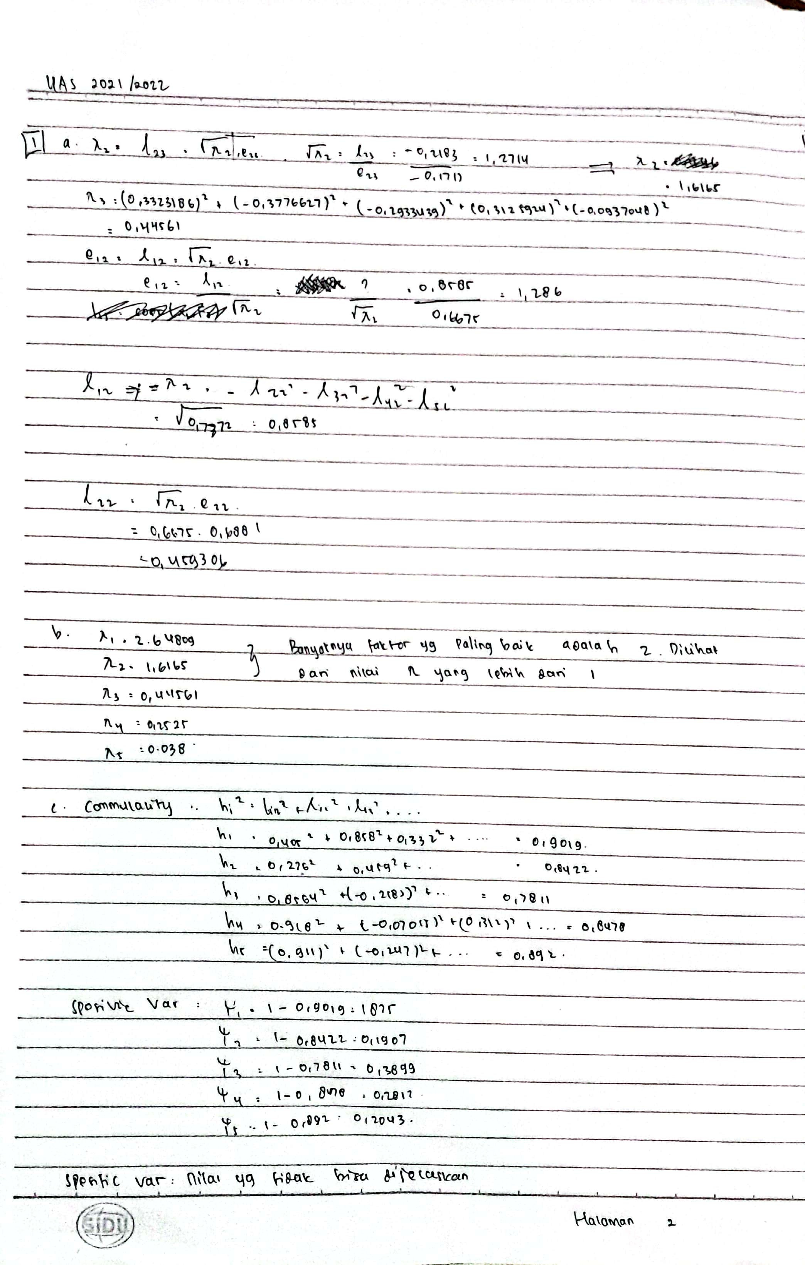



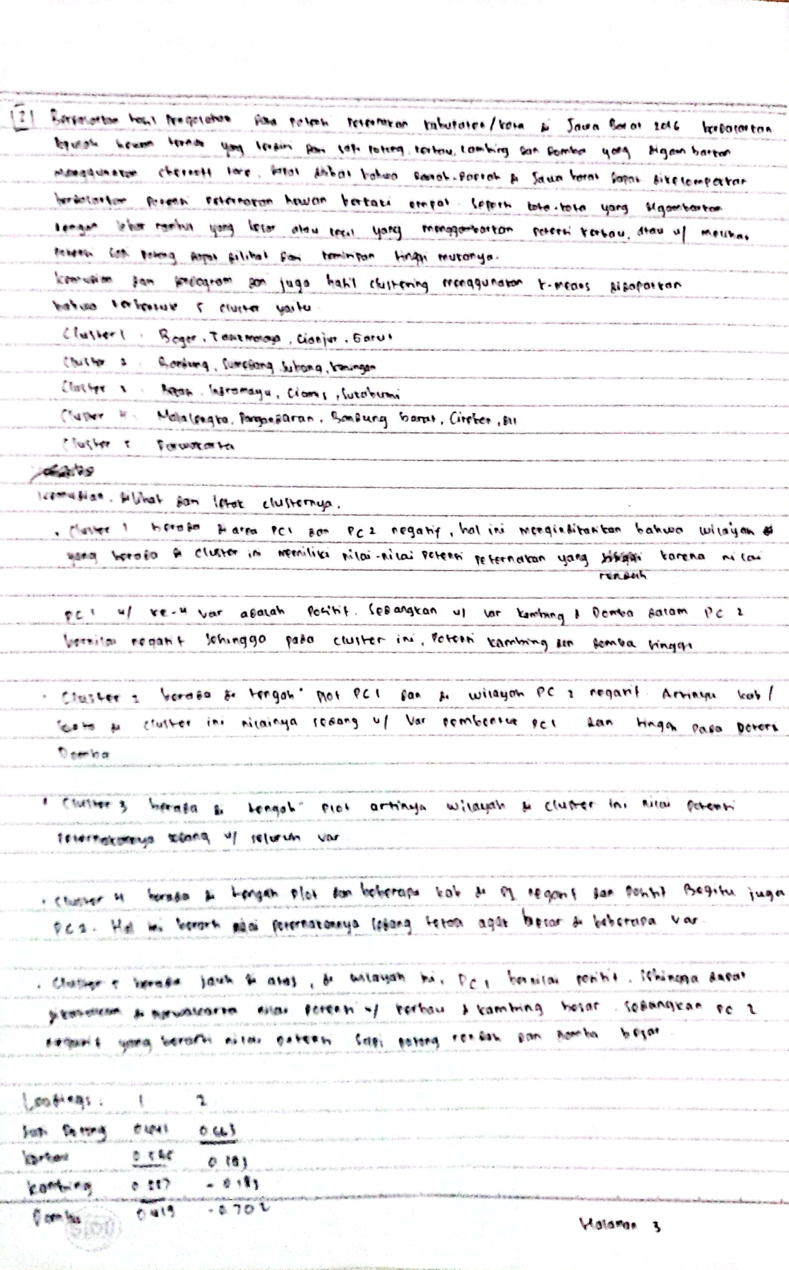

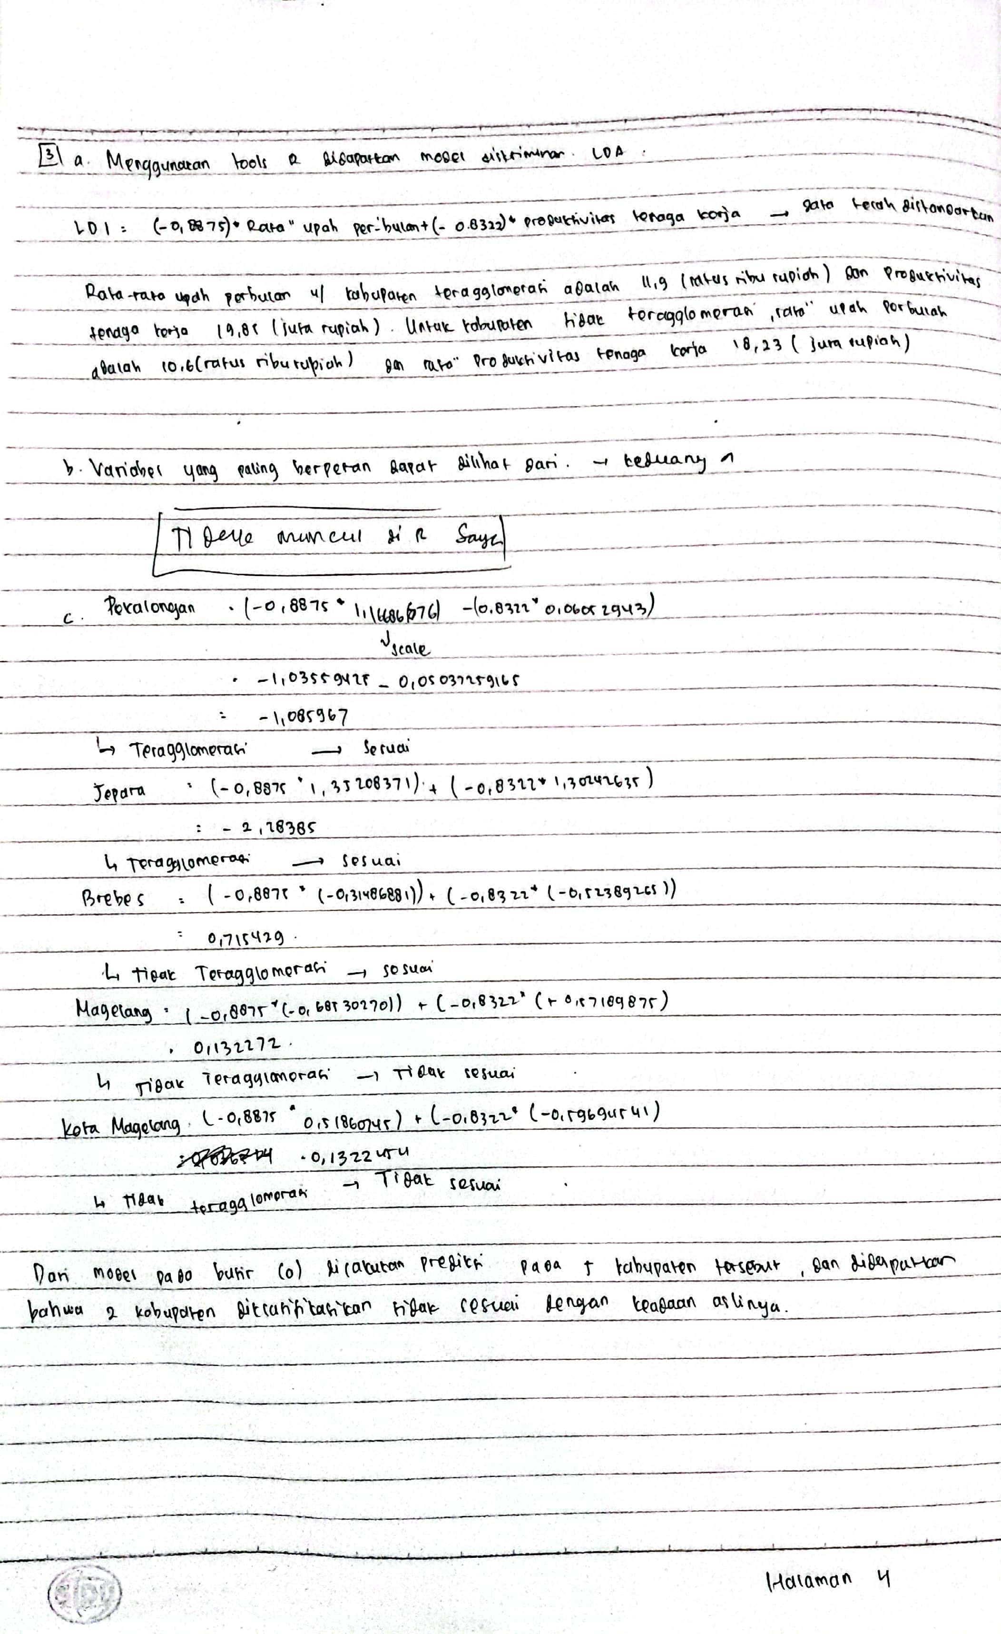

Nomor 2

library(readxl)

## Warning: package 'readxl' was built under R version 4.0.4

Data_TernakJabar16 <- read_excel("C:/Users/Asus/Downloads/20220620_3_3SD 3SI APG-1655675429849/Data_TernakJabar16.xlsx")  
Data_TernakJabar16=Data_TernakJabar16[-28:-30,]  
Data_TernakJabar16

## # A tibble: 27 x 5  
## Kab SapiPotong Kerbau Kambing Domba  
## <chr> <dbl> <dbl> <dbl> <dbl>  
## 1 Bogor 1.71 2.95 1.76 -0.169   
## 2 Sukabumi 0.200 0.925 0.711 -0.0471   
## 3 Cianjur 1.48 0.962 1.10 0.123   
## 4 Bandung 0.871 -0.0287 -0.367 -0.136   
## 5 Garut 1.03 1.37 0.829 1.22   
## 6 Tasikmalaya 2.57 1.61 1.17 0.00878  
## 7 Ciamis -0.361 -0.214 1.41 -0.248   
## 8 Kuningan 0.878 0.717 -0.716 -0.321   
## 9 Cirebon -0.771 0.0230 -0.558 -0.119   
## 10 Majalengka -0.0973 -0.408 -0.449 0.665   
## # ... with 17 more rows

## Profilling

pr = princomp(Data_TernakJabar16[,-1])  
summary(pr, loadings = TRUE)

## Importance of components:  
## Comp.1 Comp.2 Comp.3 Comp.4  
## Standard deviation 1.6142623 0.9463238 0.44232862 0.39347915  
## Proportion of Variance 0.6765168 0.2324930 0.05079495 0.04019517  
## Cumulative Proportion 0.6765168 0.9090099 0.95980483 1.00000000  
##   
## Loadings:  
## Comp.1 Comp.2 Comp.3 Comp.4  
## SapiPotong 0.441 0.663 0.354 0.490  
## Kerbau 0.565 0.183 -0.802  
## Kambing 0.557 -0.183 -0.756 0.292  
## Domba 0.419 -0.702 0.547 0.178

pr$loadings

##   
## Loadings:  
## Comp.1 Comp.2 Comp.3 Comp.4  
## SapiPotong 0.441 0.663 0.354 0.490  
## Kerbau 0.565 0.183 -0.802  
## Kambing 0.557 -0.183 -0.756 0.292  
## Domba 0.419 -0.702 0.547 0.178  
##   
## Comp.1 Comp.2 Comp.3 Comp.4  
## SS loadings 1.00 1.00 1.00 1.00  
## Proportion Var 0.25 0.25 0.25 0.25  
## Cumulative Var 0.25 0.50 0.75 1.00

Nomor 3

library(readxl)  
Data_IKRT <- read_excel("C:/Users/Asus/Downloads/20220620_3_3SD 3SI APG-1655675429849/Data_IKRT.xlsx")  
head(Data_IKRT)

## # A tibble: 6 x 5  
## No. `Kabupaten/Kota` `Rata-Rata Upah per ~ `Produktivitas Tenaga~ Kriteria   
## <dbl> <chr> <dbl> <dbl> <chr>   
## 1 1 Kota Magelang 11.8 18.2 Teragglom~  
## 2 2 Kota Surakarta 12.6 19.5 Teragglom~  
## 3 3 Kota Semarang 13.1 20.5 Teragglom~  
## 4 4 Kota Pekalongan 12.5 19.1 Teragglom~  
## 5 5 Kota Tegal 12.5 18.6 Teragglom~  
## 6 6 Sukoharjo 11.5 19.6 Teragglom~

library(MASS)

## Warning: package 'MASS' was built under R version 4.0.5

library(ggplot2)

## Warning: package 'ggplot2' was built under R version 4.0.5

Data_IKRT=Data_IKRT[-1:-2]  
Data_IKRT

## # A tibble: 35 x 3  
## `Rata-Rata Upah per bulan` `Produktivitas Tenaga Kerja` Kriteria   
## <dbl> <dbl> <chr>   
## 1 11.8 18.2 Teragglomerasi  
## 2 12.6 19.5 Teragglomerasi  
## 3 13.1 20.5 Teragglomerasi  
## 4 12.5 19.1 Teragglomerasi  
## 5 12.5 18.6 Teragglomerasi  
## 6 11.5 19.6 Teragglomerasi  
## 7 9.9 19.1 Teragglomerasi  
## 8 12.6 19.9 Teragglomerasi  
## 9 12 20.1 Teragglomerasi  
## 10 12.7 20.8 Teragglomerasi  
## # ... with 25 more rows

#scale each predictor variable  
Data_IKRT[1:2] <- scale(Data_IKRT[1:2])  
  
#find mean of each predictor variable  
apply(Data_IKRT[1:2], 2, mean)

## Rata-Rata Upah per bulan Produktivitas Tenaga Kerja   
## -1.855178e-16 -5.225432e-16

#find standard deviation of each predictor variable  
apply(Data_IKRT[1:2], 2, sd)

## Rata-Rata Upah per bulan Produktivitas Tenaga Kerja   
## 1 1

Data_IKRT[1:2]

## # A tibble: 35 x 2  
## `Rata-Rata Upah per bulan` `Produktivitas Tenaga Kerja`  
## <dbl> <dbl>  
## 1 0.519 -0.597   
## 2 1.26 0.353   
## 3 1.72 1.08   
## 4 1.17 0.0605  
## 5 1.17 -0.305   
## 6 0.241 0.426   
## 7 -1.24 0.0605  
## 8 1.26 0.645   
## 9 0.704 0.791   
## 10 1.35 1.30   
## # ... with 25 more rows

#make this example reproducible  
set.seed(1)  
  
#Use 70% of dataset as training set and remaining 30% as testing set  
sample <- sample(c(TRUE, FALSE), nrow(Data_IKRT), replace=TRUE, prob=c(0.7,0.3))  
train <- Data_IKRT[sample, ]  
test <- Data_IKRT[!sample, ]

#fit LDA model  
model <- lda(Kriteria~., data=Data_IKRT)  
  
#view model output  
model

## Call:  
## lda(Kriteria ~ ., data = Data_IKRT)  
##   
## Prior probabilities of groups:  
## Teragglomerasi Tidak Teragglomerasi   
## 0.4857143 0.5142857   
##   
## Group means:  
## `Rata-Rata Upah per bulan` `Produktivitas Tenaga Kerja`  
## Teragglomerasi 0.6275586 0.6105737  
## Tidak Teragglomerasi -0.5926942 -0.5766530  
##   
## Coefficients of linear discriminants:  
## LD1  
## `Rata-Rata Upah per bulan` -0.8874551  
## `Produktivitas Tenaga Kerja` -0.8321928

Data_IKRT[10,],Data_IKRT[20,],Data_IKRT[15,], Data_IKRT[1,]) as.data.frame(data3)

dataPekalongan=c(Data_IKRT[4,])  
#use LDA model to make predictions on test data  
predictedPekalongan <- predict(model, dataPekalongan)  
predictedPekalongan

## $class  
## [1] Teragglomerasi  
## Levels: Teragglomerasi Tidak Teragglomerasi  
##   
## $posterior  
## Teragglomerasi Tidak Teragglomerasi  
## 1 0.8938245 0.1061755  
##   
## $x  
## LD1  
## 1 -1.085914

dataJepara=c(Data_IKRT[10,])  
#use LDA model to make predictions on test data  
predictedJepara <- predict(model, dataJepara)  
predictedJepara

## $class  
## [1] Teragglomerasi  
## Levels: Teragglomerasi Tidak Teragglomerasi  
##   
## $posterior  
## Teragglomerasi Tidak Teragglomerasi  
## 1 0.9901571 0.009842937  
##   
## $x  
## LD1  
## 1 -2.283783

dataBrebes=c(Data_IKRT[20,])  
#use LDA model to make predictions on test data  
predictedBrebes <- predict(model, dataBrebes)  
predictedBrebes

## $class  
## [1] Tidak Teragglomerasi  
## Levels: Teragglomerasi Tidak Teragglomerasi  
##   
## $posterior  
## Teragglomerasi Tidak Teragglomerasi  
## 1 0.1679835 0.8320165  
##   
## $x  
## LD1  
## 1 0.7154116

dataMGL=c(Data_IKRT[15,])  
#use LDA model to make predictions on test data  
predictedMGL <- predict(model, dataMGL)  
predictedMGL

## $class  
## [1] Tidak Teragglomerasi  
## Levels: Teragglomerasi Tidak Teragglomerasi  
##   
## $posterior  
## Teragglomerasi Tidak Teragglomerasi  
## 1 0.4031648 0.5968352  
##   
## $x  
## LD1  
## 1 0.1322454

dataKotaMGL=c(Data_IKRT[15,])  
#use LDA model to make predictions on test data  
predictedKotaMGL <- predict(model, dataKotaMGL)  
predictedKotaMGL

## $class  
## [1] Tidak Teragglomerasi  
## Levels: Teragglomerasi Tidak Teragglomerasi  
##   
## $posterior  
## Teragglomerasi Tidak Teragglomerasi  
## 1 0.4031648 0.5968352  
##   
## $x  
## LD1  
## 1 0.1322454